Top Talent Driver Web Application: High-Level Design Document
Application High Level Design (HLD) | Version 1.0
Version | 1.0
Date | 12/08/2026
Application | Top Talent Driver Web Application
Submission Intent | Security / SPDA submission version focused on dashboard, analytics consumption, controlled data access, and chatbot capabilities
Design Basis | Content taken from the supplied Top Talent Driver source document.

Summary
The Top Talent Driver Web Application is a ReactJS and GCP based analytics and insight delivery platform designed to help HR and business users understand the drivers behind top talent nomination across Vodafone markets. It provides a single interface for viewing analytics model outputs, including global predictor insights and market-level driver and barrier analysis, and includes an in-dashboard chatbot capability in phase 2.
The application is a presentation and query layer only. Analytical modelling is performed upstream by the analytics team, with published outputs consumed from BigQuery. Data access is controlled through authentication and group-based authorization, with backend enforcement on every request.

1. Frontend Architecture

1.1 Technology Stack
- Framework: ReactJS single page application.
- Host Platform: Google Cloud Run.
- User Experience: Interactive dashboard views for Top Talent Driver insights.
- Transport: Frontend-to-backend API communication over HTTPS / TLS using REST APIs and JWT-based request context.

1.2 Feature Modules

1.2.1 Top Talent Driver Dashboard
- Provides a single place for HR and business users to view the drivers behind top talent nominations across Vodafone markets.
- Supports Top Talent Drivers visualization, including the global predictor view and market-level driver and barrier views.
- Renders the driver's visualizations using scoped results returned by the backend API.

1.2.2 Data Filtering and Scope-Based Views
- Users view data only within the scope resolved for their group, market, and access level.
- Data access logic is not held in the frontend. All data requests are handled by the backend, which applies to the user's assigned access level and scope of permissions before returning data.
- Row-level security is enforced in BigQuery using Row Access Policies. User access is determined by Google Group membership, ensuring users can only view data for their authorized market, region, or organizational scope.
- Column-level security is enforced in BigQuery using Policy Tags and Data Policies. Sensitive columns and other confidential attributes are restricted or masked based on the user's assigned permissions and access level.

1.3 Authentication Integration
- Users reach the application through Cloud Load Balancing, Cloud Armor and Identity-Aware Proxy.
- Production authentication uses corporate SSO through Azure AD using SAML 2.0.
- Application-level authorization checks are enforced by the backend before data access is granted. Phase 1 uses Google Group-based access control. Phase 2 introduces L1 and L2 authorization levels to provide enhanced role-based access management.

1.4 Frontend Dependencies
Package | Version | Type
react | 19.2.6 | Dependency
react-dom | 19.2.6 | Dependency
@eslint/js | 10.0.1 | Dev Dependency
@types/node | 24.12.3 | Dev Dependency
@types/react | 19.2.14 | Dev Dependency
@types/react-dom | 19.2.3 | Dev Dependency
@vitejs/plugin-react | 6.0.1 | Dev Dependency
eslint | 10.3.0 | Dev Dependency
eslint-plugin-react-hooks | 7.1.1 | Dev Dependency
eslint-plugin-react-refresh | 0.5.2 | Dev Dependency
globals | 17.6.0 | Dev Dependency
typescript | 6.0.2 | Dev Dependency
typescript-eslint | 8.59.2 | Dev Dependency
vite | 8.0.12 | Dev Dependency

2. Backend Architecture

2.1 Core Services

2.1.1 Backend API Layer (Cloud Run)
- The backend API layer runs on Cloud Run and is built with Fast API / Express.js.
- It validates incoming requests, authorizes them against the user group and level, queries BigQuery, and returns scoped results to the frontend.
- The backend acts as the controlled processing boundary between the frontend, access control store, BigQuery datasets, and chatbot agent.

2.1.2 Data Storage and Retrieval - BigQuery
- The application consumes published analytics outputs and semantic views stored in BigQuery.
- Analytics outputs are held in project vf-cip-ca-nonlive, dataset vfcip_lake_all_hrdata_sf_semantic_analytics_processed_s.
- Published output views include top_talent_analytics, top_talent_descriptive_stats, and top_talent_prevalance_summary.
- Supporting semantic views are held in project vf-cip-datahub, dataset vfcip_dh_lake_all_hrdata_sf_semantic_processed_s.
- Semantic views include ViewAppHRBPMonthly, ViewAppHRBPTalentKPI, ViewEmployeeInfoDataAnalytics, and ViewVLOLearningDashboard.

2.1.3 Access Control Store
- The access model resolves users to either a Vodafone Group scope or a Local Market scope based on Google Group membership. BigQuery row-level access policies enforce market-specific data visibility. Phase 2 will introduce L1 and L2 authorization levels to further refine access permissions and data visibility.
- Scope is hierarchical, so a user may be assigned to a single market and within that market only a specific location. Column-level controls can be applied to sensitive attributes, ensuring that access to confidential or personally identifiable information is granted only to authorized user groups while remaining hidden or masked for other users.

2.2 Backend Dependencies
Package | Version | Type
@google-cloud/bigquery | 8.3.1 | Dependency
compression | 1.8.1 | Dependency
cors | 2.8.6 | Dependency
dotenv | 17.4.2 | Dependency
express | 5.2.1 | Dependency
helmet | 8.1.0 | Dependency
tsx | 4.22.0 | Dependency
@types/compression | 1.8.1 | Dev Dependency
@types/cors | 2.8.19 | Dev Dependency
@types/express | 5.0.6 | Dev Dependency
@types/node | 25.8.0 | Dev Dependency

2.3 User Scope and Data Access

2.3.1 User Access Resolution
- After authentication, the backend resolves the user's access scope based on Google Group membership and applicable BigQuery access policies.
- The resolved scope establishes the user group, market and level before dashboard data is retrieved.

2.3.2 Data Filtering and Scope Enforcement
- All dashboard requests are processed through the backend API layer.
- BigQuery queries are filtered to the user permitted scope.
- Access control is enforced in the backend and not in the frontend application.

3. Infrastructure and Deployment
The Top Talent Driver Web Application is deployed on GCP using Cloud Run for the ReactJS frontend and backend API layer. BigQuery serves as the interface between the upstream analytics work and the application. The application reads published BigQuery views and does not hold its own copy of HR data.
Figure 1. Top Talent Driver Web Application - Solution Architecture
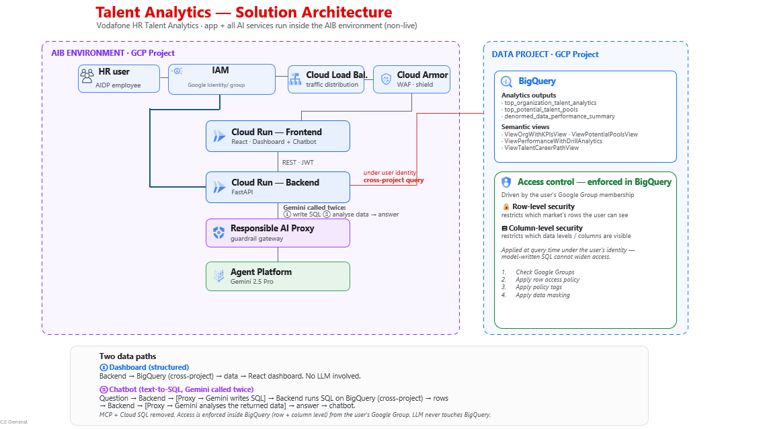

3.1 End-to-End Data Flow
- Access and authentication: The user reaches the application through Cloud Load Balancing and Cloud Armor. Identity-Aware Proxy authenticates the user against Azure AD corporate SSO using SAML 2.0.
- Access resolution: The authenticated identity is resolved against Google Group membership and mapped to the appropriate access scope and access level. Data access is subsequently enforced through BigQuery access controls and associated permissions.
- Dashboard request: The ReactJS frontend requests dashboard data from the backend API over REST.
- Authorization: The backend validates the authenticated user context and applies the user's Google Group membership (Vodafone Group or Local Market) and access level (L1 or L2) before any data is read.
- Data retrieval: The backend queries relevant analytics output and semantic views in BigQuery, filtered to the permitted scope.
- Rendering: The backend returns scoped data and the frontend renders the driver visualizations.
- Chatbot processing: The frontend sends questions to the backend, which calls the AI Booster agent over REST with SSE using service-to-service authentication and the authenticated user's Google Group context.
- AI response: The agent uses Firestore session context, queries BigQuery through the managed BigQuery MCP server, and calls Vertex AI Gemini 2.5 Pro through the Responsible AI proxy.

3.2 Environment Architecture
- The Top Talent Driver Web Application follows Vodafone's multi-project GCP architecture, with separate environments for development and production workloads.
- Application services, including the ReactJS frontend and backend API, are deployed on Cloud Run
- Development and production environments are maintained separately in accordance with Vodafone GCP governance standards. Access to the development environment is restricted through Google Group membership, ensuring that only authorized users can access application resources, configurations, and datasets.
- Phase 2 will introduce role-based access levels, including L1 and L2, to provide more granular control over data access and application functionality based on user scope and responsibilities.
- Monitoring, logging, and audit activities are centrally managed using Google Cloud services.

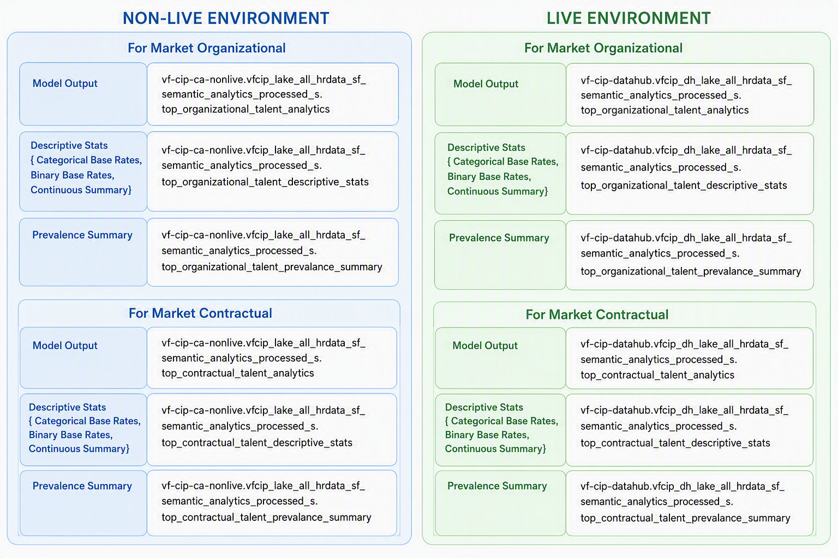

Component | Non-live | Live
Environment | vf-cip-ca-nonlive | vf-cip-datahub
Purpose | Testing | Production
Support Impact | Validation and test | Product Operations

3.3 Scaling and Availability Configuration
- Cloud Run dynamically adjusts the number of application instances to support varying usage patterns while optimizing resource utilization.
- Cloud Load Balancing distributes incoming requests across available service instances to maintain application responsiveness and availability.
- The architecture leverages GCP services to support high availability, operational resilience, and minimal infrastructure management overhead.

4. Security and Compliance

4.1 Data Privacy
- The analysis covers sensitive data, including demographic factors and identified bias patterns.
- Distribution should use controlled, group-based access rather than shared files.
- The application reads published views and does not hold its own copy of HR data.

4.2 Data Classification and Labelling
- The supplied Top Talent source confirms the application handles sensitive analytics data. Detailed classification labeling is to be confirmed.

4.3 PII Handling and Filtering
- The application should return only the data the user is entitled to see, with filtering applied by the backend before the data is returned to the frontend.
- Phase – 1: Access control is based on Google Groups membership.
- Phase – 2: SSO (Azure AD via Identity-Aware Proxy) will be implemented to provide centralized authentication and user access management

4.4 Encryption and Key Management
- All communications are protected using HTTPS encryption in transit. Data stored in BigQuery is encrypted at rest using Google Cloud managed encryption keys.

4.5 Logging for Unauthorized Access
- Logging and audit of application activity are in scope for Phase 1.

4.6 Monitoring
- Operational logs and monitoring should cover application activity, authorization denials, API failures and BigQuery usage or failures.

4.7 Ensuring Secure Data Sources
- BigQuery is the controlled interface between the analytics work and the application.
- Analytics model outputs and semantic views are produced and refreshed upstream of the application.
- The application consumes published outputs and does not change the underlying HR data pipelines.

4.8 Key Security Risks and Mitigation

Risk | Description | Mitigation
Sensitive analytics data | The solution exposes talent analytics and data that includes demographic factors and bias-pattern analysis. | Use controlled, group-based access and backend entitlement enforcement for every request.
Service-account overreach | Broad runtime permissions could expand the attack surface. | Scope Cloud Run, BigQuery, Firestore and Secret Manager access using the least privilege and include permissions in security review.
Unauthorized data scope exposure | Users could see a broader population than intended if scope checks are misconfigured. | Resolve user membership centrally through Google Groups/IAM and enforce access in BigQuery using Row-Level Security, Column-Level Security, and Data Masking before results are returned to the backend.
AI response governance | The chatbot could answer outside the permitted data context if not controlled. | Use the governed AI Booster agent path, Responsible AI proxy, BigQuery MCP server and user-context enforcement.

5. Monitoring and Observability

5.1 Cloud Logging Query
- Application and infrastructure logs are collected through Google Cloud's managed logging capabilities.
- Logs from Cloud Run services are used for troubleshooting, operational monitoring, and error analysis.

5.2 API Performance Tracking
- Track API request success rate and failure rate.
- Track dashboard data retrieval behavior and BigQuery operation outcomes.
- Track authorization denials and abnormal error conditions.

6. Future Roadmap

6.1 Enhancements Roadmap
Phase 1 (Initial Release)
- Dashboard view with core analytics and driver visualizations.
- Access management through Google Groups (Google Workspace) for user authorization and data filtering.
Phase 2 (Planned Enhancements)
- Corporate SSO integration using Azure AD and Identity-Aware Proxy.
- Introduction of L1 and L2 access levels with enhanced authorization controls.
- Chatbot functionality for natural language querying and insights.
- Simulation view allowing users to adjust factors such as impact rating or recent promotions and evaluate changes in relative odds against a baseline.
- Overview page providing a consolidated summary of key metrics and insights.

7. Technical Specifications

7.1 System Requirements
- Frontend: ReactJS application hosted on Cloud Run.
- Backend: Cloud Run API layer using FastAPI / Express.js.
- Data: BigQuery analytics outputs and semantic views.
- Access: Cloud Load Balancing, Cloud Armor, Identity-Aware Proxy, Azure AD SSO using SAML 2.0.
- AI: AI Booster agent, Vertex AI Gemini 2.5 Pro through Responsible AI proxy, BigQuery MCP server, Firestore and Secret Manager.

7.2 Dependencies
- ReactJS for the frontend application.
- Cloud Run for frontend and backend services.
- BigQuery for analytics outputs and semantic views.
- Google Groups and BigQuery access policies for access control.
- Identity-Aware Proxy, Azure AD SSO and Cloud Armor for identity and edge security.
- AI Booster, Vertex AI Gemini 2.5 Pro, Responsible AI proxy, BigQuery MCP server, Firestore and Secret Manager for chatbot capability.

7.3 Service Accounts and IAM Permissions
- Service accounts are used for secure communication between Google Cloud services within the Top Talent Driver solution.
- Access to analytics datasets, application resources, and administrative operations is controlled through role-based permissions and organizational access policies

8. CI/CD Environments and Processes
- Application changes are developed and tested in the development environment before being promoted to higher environments.
- Source code is managed in GitHub using a branch-based workflow, with changes submitted through pull requests and reviewed before being merged into the main branch.
- The ReactJS frontend and backend API are packaged as Docker container images during the build process.
- CI/CD pipelines automatically build and validate application changes following code commits and merges in GitHub.
- Production deployments are executed through the Platform Team in accordance with the established release process.

9. Backup & Restore / Single Point of Failure
- Application container images are stored in Artifact Registry, enabling recovery and redeployment of approved application versions when required.
- Access control can be restored through recovery of Google Group and BigQuery security configurations.

